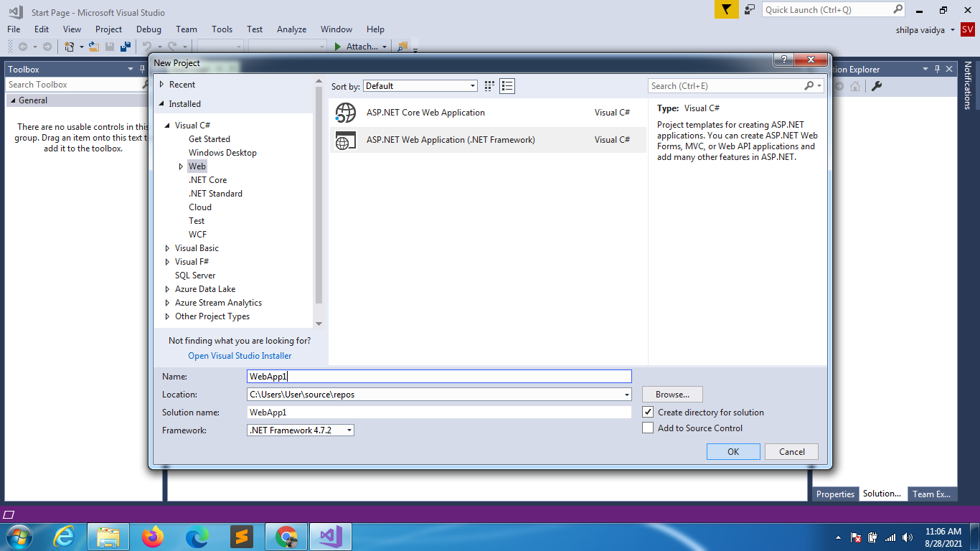

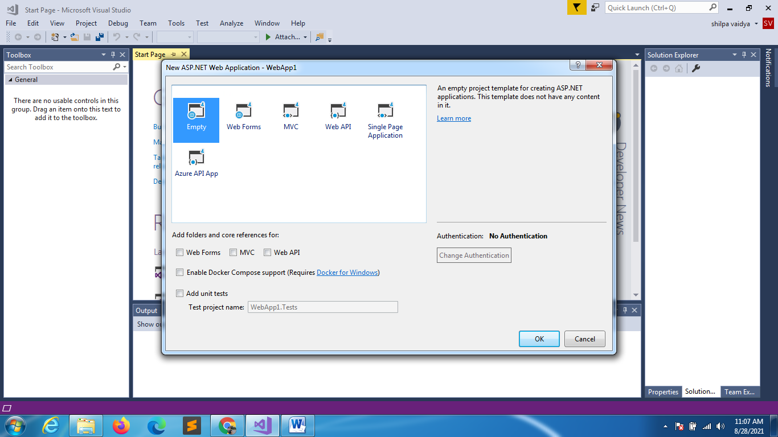

INDEX->WEBFORM

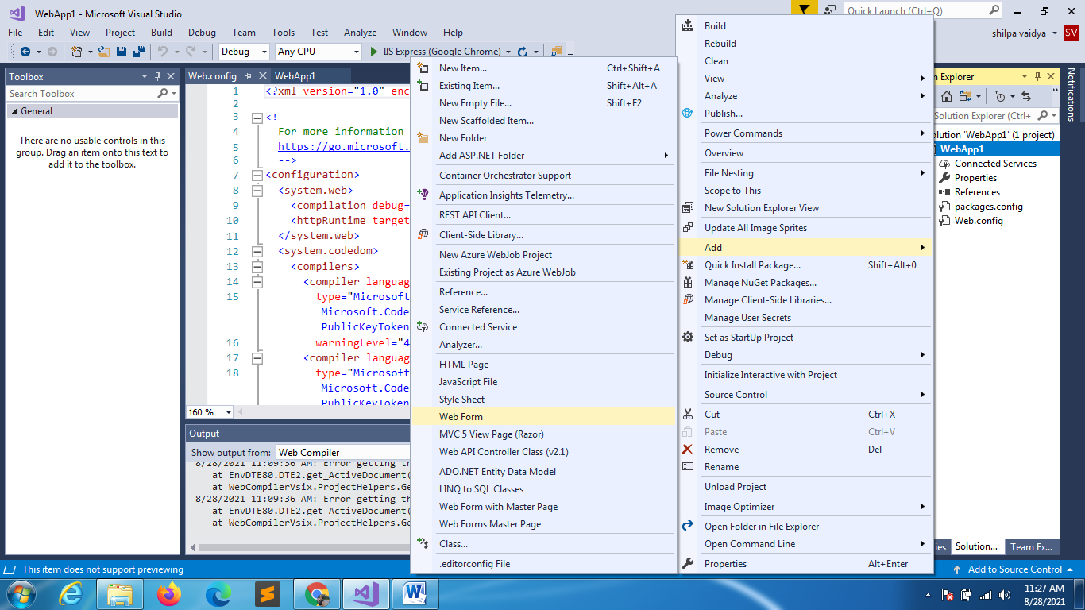

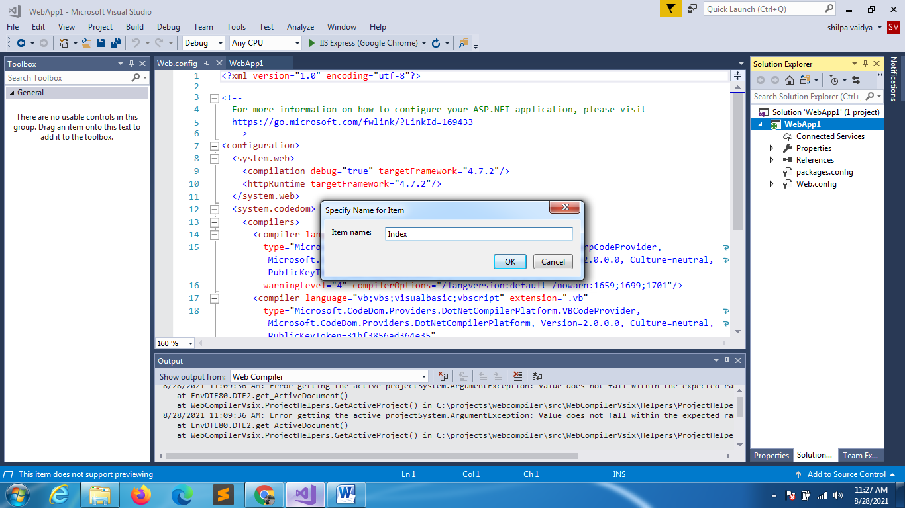

Web Config file

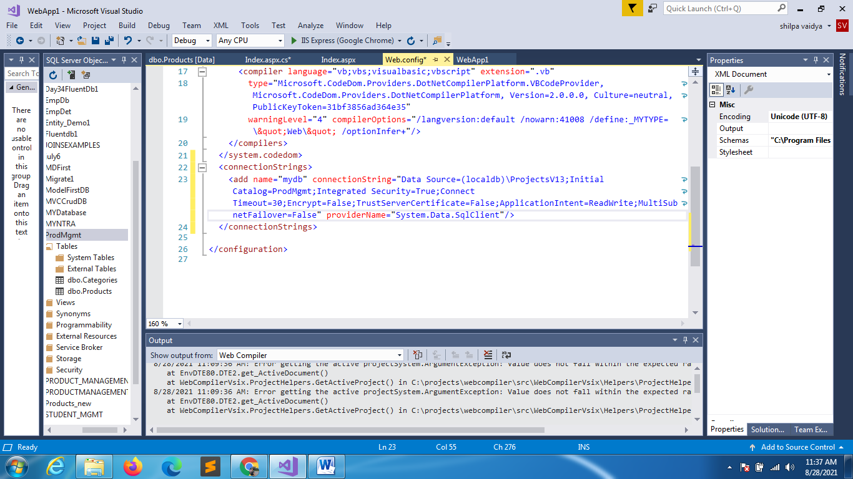

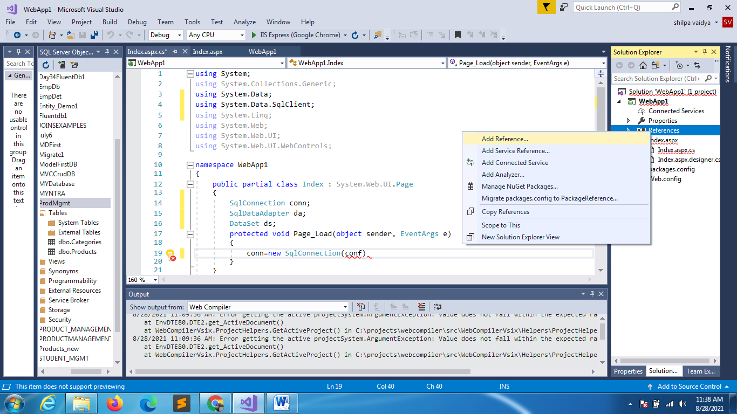

Check if the Configuration is checked

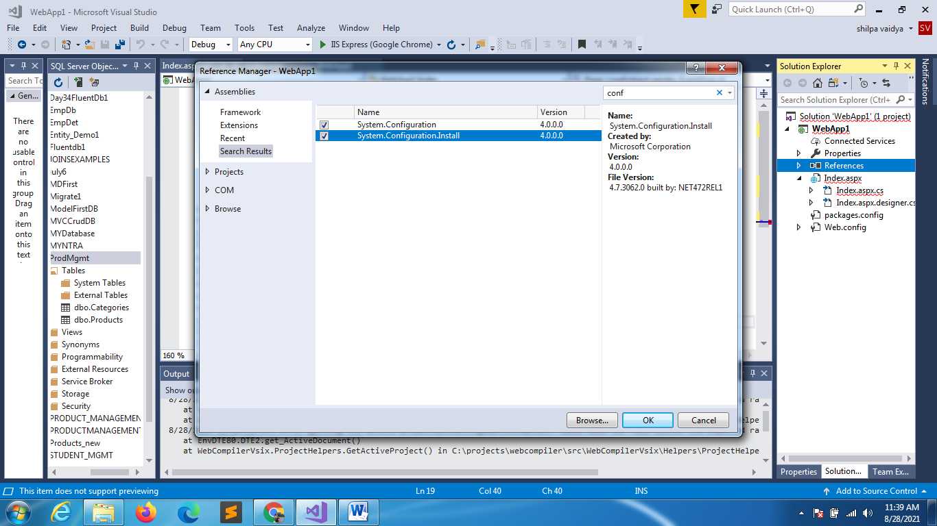

DRAG AND DROP GRID VIEW

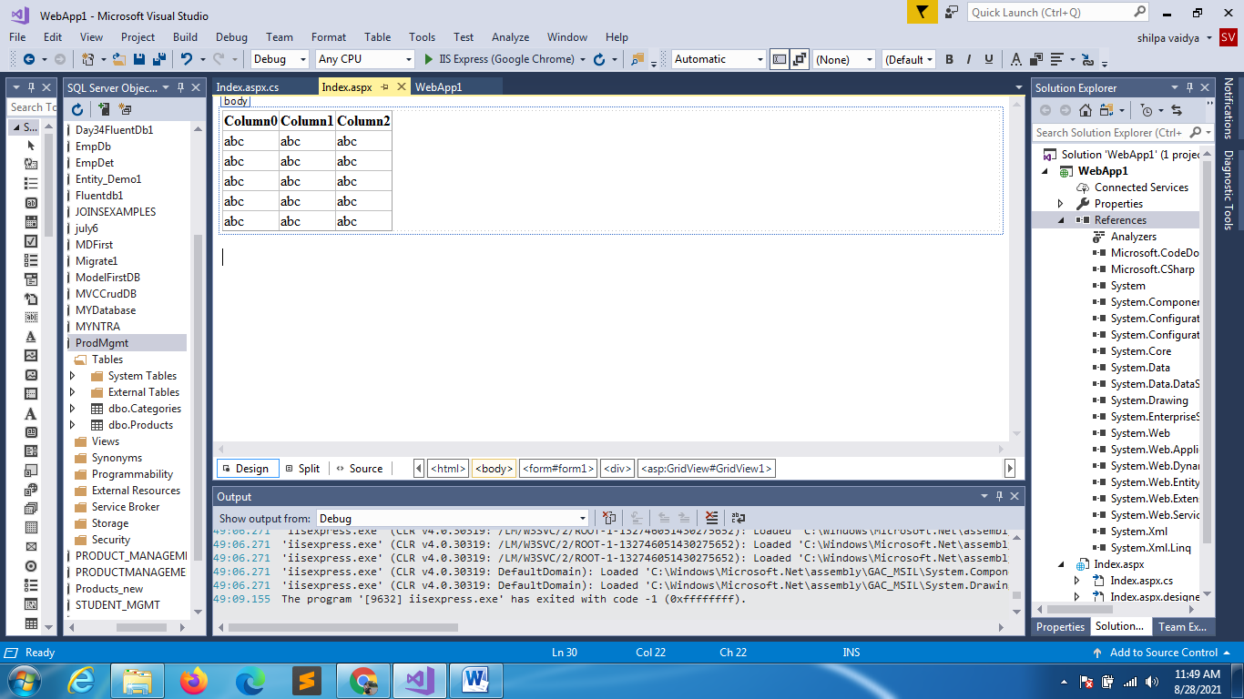

INDEX.ASPX.CS

using System;

using System.Collections.Generic;

using System.Data;

using System.Data.SqlClient;

using System.Linq;

using System.Web;

using System.Web.UI;

using System.Web.UI.WebControls;

using System.Configuration;

namespace WebApp1

{

    public partial class Index : System.Web.UI.Page

    {

        SqlConnection conn;

        SqlDataAdapter da;

        DataSet ds;

        protected void Page_Load(object sender, EventArgs e)

        {

            conn = new SqlConnection(ConfigurationManager.ConnectionStrings["mydb"].ConnectionString);

            da = new SqlDataAdapter("select * from Products",conn);

            ds = new DataSet();

            da.Fill(ds, "Products");

            GridView1.DataSource = ds.Tables["Products"];

            GridView1.DataBind();

        }

    }

}

SINCE WE DON’T USE TRY CATCH BLOCK WILL TRY TO GET A PAFE LEVEL ERROR HANDLER

using System;

using System.Collections.Generic;

using System.Data;

using System.Data.SqlClient;

using System.Linq;

using System.Web;

using System.Web.UI;

using System.Web.UI.WebControls;

using System.Configuration;

namespace WebApp1

{

    public partial class Index : System.Web.UI.Page

    {

PUT A WRONG CONN STRING NAME

        SqlConnection conn;

        SqlDataAdapter da;

        DataSet ds;

        protected void Page_Load(object sender, EventArgs e)

        {

            conn = new SqlConnection(ConfigurationManager.ConnectionStrings["mydb1"].ConnectionString);

            da = new SqlDataAdapter("select * from Products",conn);

            ds = new DataSet();

            da.Fill(ds, "Products");

            GridView1.DataSource = ds.Tables["Products"];

            GridView1.DataBind();

        }

    }

}

YOU WILL GET ERROR

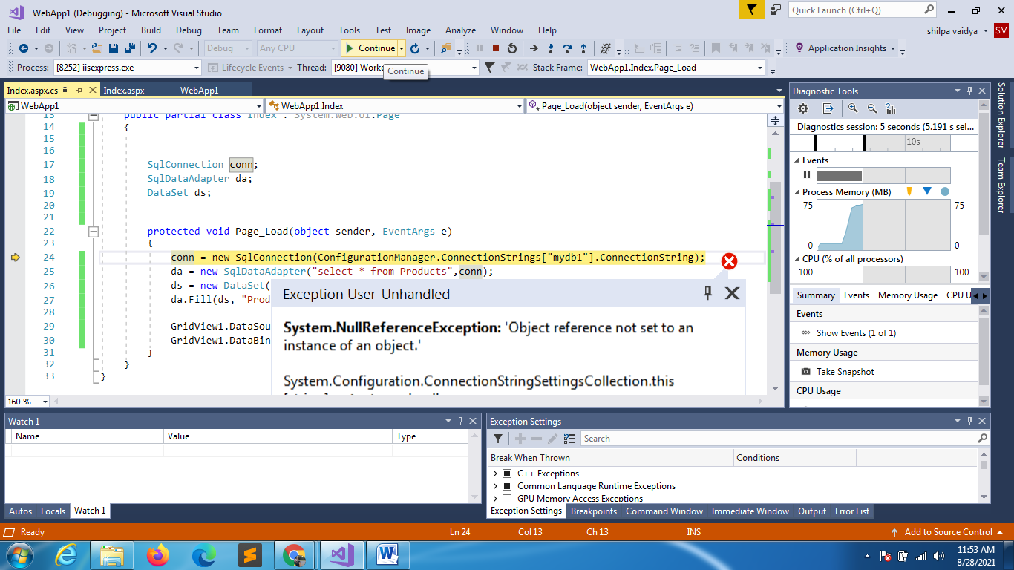

Create an Error.html Page

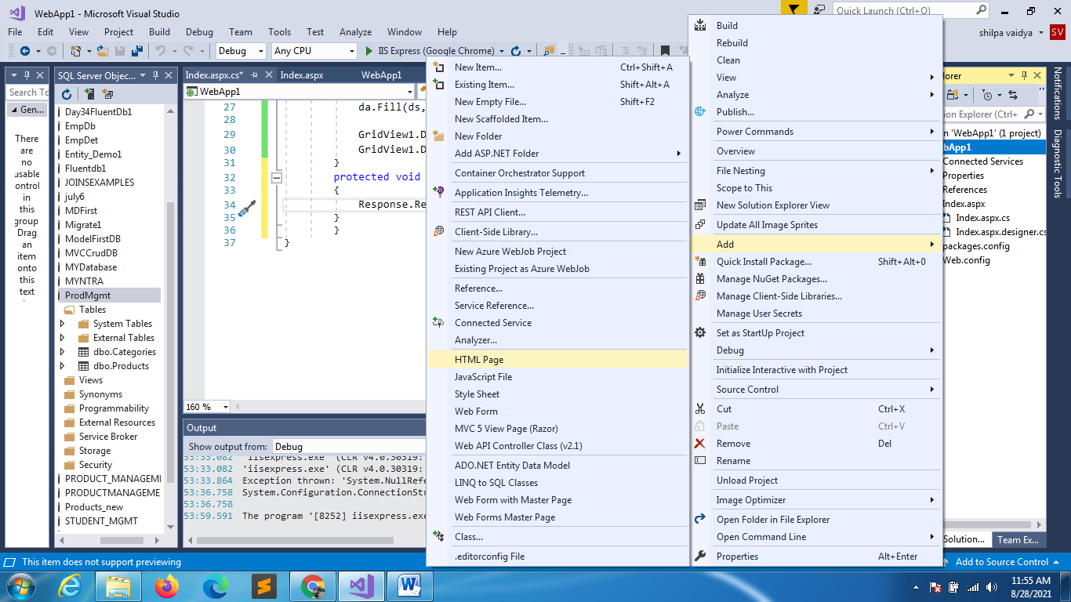

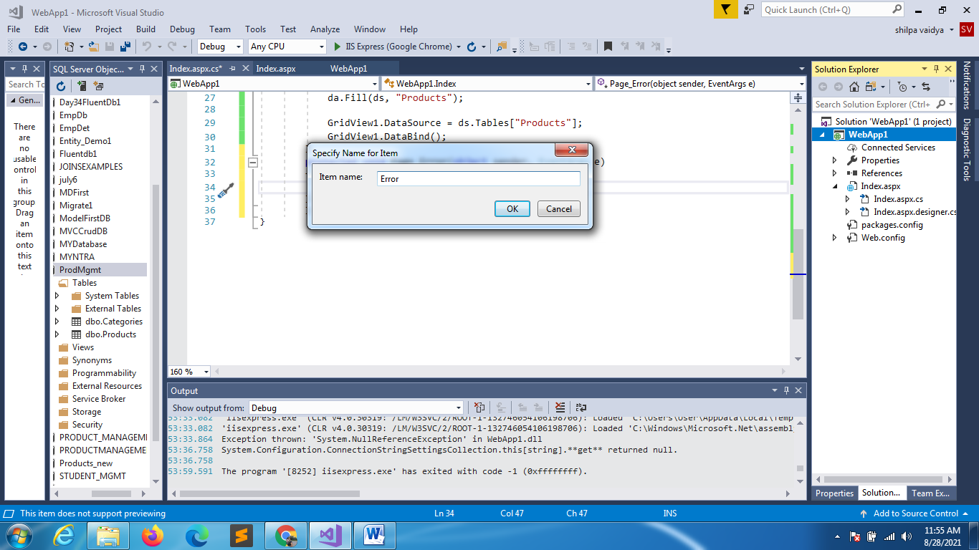

<!DOCTYPE html>

<html>

<head>

    <meta charset="utf-8" />

    <title></title>

</head>

<body>

    <h2>HEY THERE IS SOME ERROR !!!</h2>

</body>

</html>

using System;

using System.Collections.Generic;

using System.Data;

using System.Data.SqlClient;

using System.Linq;

using System.Web;

using System.Web.UI;

using System.Web.UI.WebControls;

using System.Configuration;

namespace WebApp1

{

    public partial class Index : System.Web.UI.Page

    {

        SqlConnection conn;

        SqlDataAdapter da;

        DataSet ds;

        protected void Page_Load(object sender, EventArgs e)

        {

            conn = new SqlConnection(ConfigurationManager.ConnectionStrings["mydb1"].ConnectionString);

            da = new SqlDataAdapter("select * from Products",conn);

            ds = new DataSet();

            da.Fill(ds, "Products");

            GridView1.DataSource = ds.Tables["Products"];

            GridView1.DataBind();

        }

        protected void Page_Error(object sender, EventArgs e)

        {

            Response.Redirect("~/Error.html");

        }

        }

}

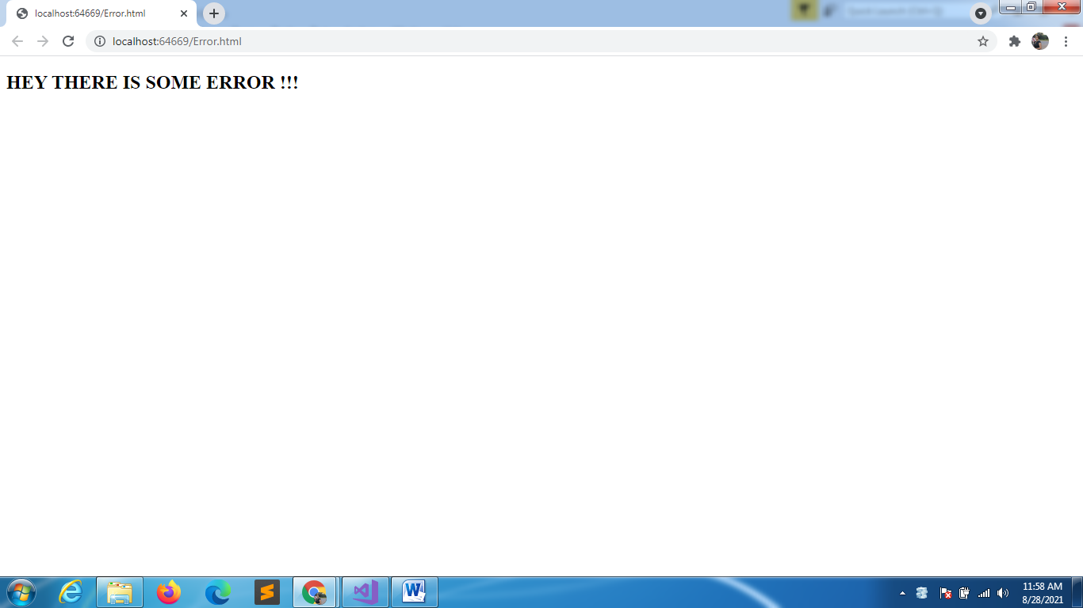

using System;

using System.Collections.Generic;

using System.Data;

using System.Data.SqlClient;

using System.Linq;

using System.Web;

using System.Web.UI;

using System.Web.UI.WebControls;

using System.Configuration;

namespace WebApp1

{

    public partial class Index : System.Web.UI.Page

    {

        SqlConnection conn;

        SqlDataAdapter da;

        DataSet ds;

        protected void Page_Load(object sender, EventArgs e)

        {

            conn = new SqlConnection(ConfigurationManager.ConnectionStrings["mydb1"].ConnectionString);

            da = new SqlDataAdapter("select * from Products",conn);

            ds = new DataSet();

            da.Fill(ds, "Products");

            GridView1.DataSource = ds.Tables["Products"];

            GridView1.DataBind();

        }

        protected void Page_Error(object sender, EventArgs e)

        {

//if you want to handle exception

            Exception ex = Server.GetLastError();

            Server.ClearError();

            Response.Redirect("~/Error.html");

        }

    }

}

using System;

using System.Collections.Generic;

using System.Data;

using System.Data.SqlClient;

using System.Linq;

using System.Web;

using System.Web.UI;

using System.Web.UI.WebControls;

using System.Configuration;

namespace WebApp1

{

    public partial class Index : System.Web.UI.Page

    {

        SqlConnection conn;

        SqlDataAdapter da;

        DataSet ds;

        protected void Page_Load(object sender, EventArgs e)

        {

            conn = new SqlConnection(ConfigurationManager.ConnectionStrings["mydb1"].ConnectionString);

            da = new SqlDataAdapter("select * from Products",conn);

            ds = new DataSet();

            da.Fill(ds, "Products");

            GridView1.DataSource = ds.Tables["Products"];

            GridView1.DataBind();

        }

        protected void Page_Error(object sender, EventArgs e)

        {

            Exception ex = Server.GetLastError();

            Server.ClearError();

            Server.Transfer("~/Error.html"); //url doesn’t change but error will occur

        }

    }

}

IF YOU CHOSE THE WEB FORMS WHILE CREATING APPLICATION

YOU CAN DO APPLICATION LEVEL ERROR HANDLING USING GLOBAL.ASPX

void Application_Error(object sender, EventArgs e)

{

            Exception ex = Server.GetLastError();

            Server.ClearError();

            Server.Transfer("~/Error.html");

}